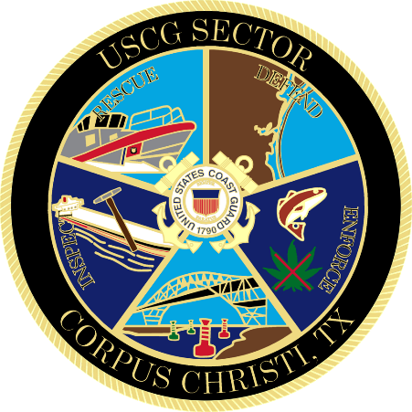

Marine Safety Information Bulletin

xx-24

Worksite – CCSC, Inner Harbor

Issue Date: April xx, 2024

The Captain of the Port is establishing a worksite in the Corpus Christi Ship Channel, Inner Harbor, from Epic West Dock across the channel to near Bulk Dock 2. Callan Marine has informed the U.S. Coast Guard that they will be removing 2 pieces of a submerged pipeline in the Inner Harbor, on April 26, 2024 from 10 a.m. to 2 p.m. This operation may impact navigation and may require vessels to take appropriate action for the protection of personnel, vessels, and the marine environment. The coordinates of the work area are: 27°49'5.55”N, 97°27'59.88”W; 27°48'58.51”N, 97°28'5.89”W; 27°49'2.45”N, 97°28'20.62”W; 27°49'9.68”N, 97°28'19.098”W. No vessels should transit through the work area without coordinating through the U.S. Coast Guard. The operation will obstruct all ship and barge traffic during this 4-hour window. The M/V SARATOGA, M/V CORAL SEA, M/V YELLOW EDGE and DREDGE GENERAL MARSHALL will be monitoring VHF channel 12 and 80.

Concerned parties with urgent concerns can contact the U.S. Coast Guard Sector Corpus Christi Command Center at 1-800-874-2143; or for non-urgent questions and concerns, email CCWaterways@uscg.mil.

- GAROFALO
Lieutenant Commander, U.S. Coast Guard
Sector Corpus Christi
By Direction of the Captain of the Port

