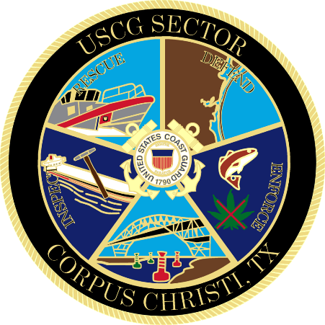

Marine Safety Information Bulletin

13-24, Update 6

Worksite – CCSC, Inner Harbor, near Chemical Turning Basin

Issue Date: April 15, 2024

Great Lakes Dredge and Dock Co. has informed the U.S. Coast Guard that will continue the dredging operations that may impact navigation in the Corpus Christi Ship Channel near the Chemical Turning basin from April 15, 2024 through May 31st, 2024 between the hours of 8pm and 6am of the next day, every day. This operation may impact navigation and may require vessels to take appropriate action for the protection of personnel, vessels, and the marine environment. The coordinates of the work area are: 27°49'27.7”N, 97°26'38.7”W; 27°49'27.2”N, 97°26'18.4”W; 27°49'23.0”N, 97°26'18.5”W; 27°49'19.5”N, 97°26'34.9”W. No vessels 500GT or greater should transit through the work site without coordinating through the U.S. Coast Guard. The operation will obstruct all ship and barge traffic during this 8-hour window. Tugs may still use the channel during this 8-hour window but are requested to make passing arrangements with GLDD vessels on-scene. The M/V ELIANA M GONDRAN, M/V KJ LEBOEUF, M/V COASTAL DAWN and M/V MR. THOMAS will be monitoring VHF channel 10, 12 and 16.

Concerned parties with urgent concerns can contact the U.S. Coast Guard Sector Corpus Christi Command Center at 1-800-874-2143; or for non-urgent questions and concerns, email CCWaterways@uscg.mil.

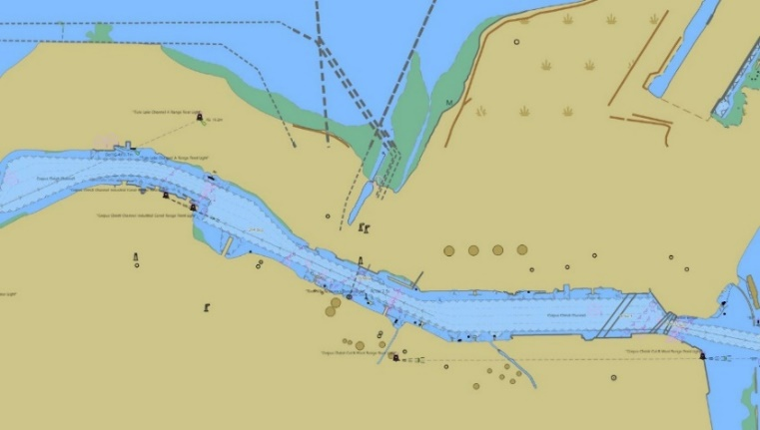

- W. METZ
Commander, U.S. Coast Guard
Sector Corpus Christi
By Direction of the Captain of the Port

